CS3402 Tutorial 1 (Introduction and ER Model):

1. Below are some sample data stored in an Excel file.
2. Identify *entity*, *entity set*, *attribute*, *relationship*, *relationship set* in this application.
3. Is there any *integrity constraint* in this application? If so, is it possible or easy to make sure the constraint(s) is not violated in Excel?

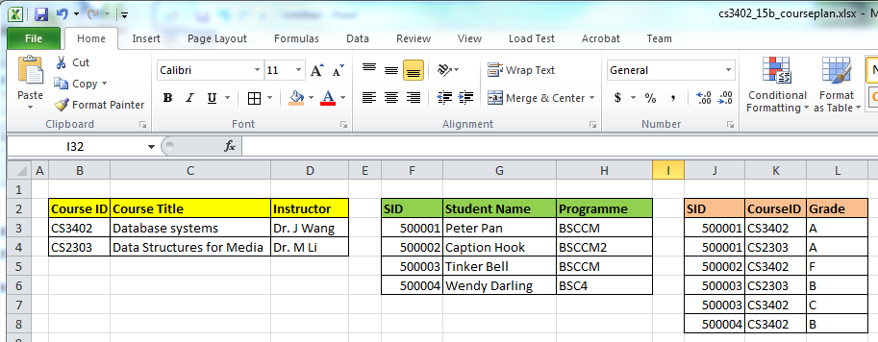

1. Construct an ER diagram for a car insurance company with a set of customers, each of whom owns a number of cars. Each car has a number of recorded accidents associated with it.
2. Construct an ER diagram for a hospital with a set of patients and a set of medical doctors. A log of the various conducted tests and results is associated with each patient.

CS3402 Tutorial 1:

1. **Answer**:

(a)

*Entity*: every single course, each individual student, each instructor

*Entity set*: the set of students, the set of courses, and the set of instructors

*Attributes*: CourseID, Course Title, Student ID, Student Name, Student Programme, Student Grade (an attribute of a relationship)

*Relationship*: Dr. J Wang teaching CS3402, Dr. M Li teaching CS2303, student Peter Pan taking course CS2303, student Caption Hook taking course CS3402 …

*Relationship set*: the set of relationships of which students taking which courses, the set of relationships of which teacher teaching which course

(b)

*Integrity Constraints*: no two students having the same SID, no two courses having the same course ID, the relationship between COURSE and STUDENT is many to many, the relationship between COURSE and INSTRUCTOR is one to one, COURSE total participate in the relationship to INSTRUCTOR ….

It is not easy or even possible to maintain integrity constraints in Excel.

1. **Answer**:

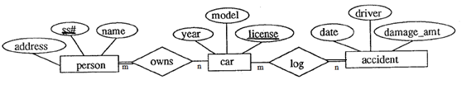

1. **Answer**:

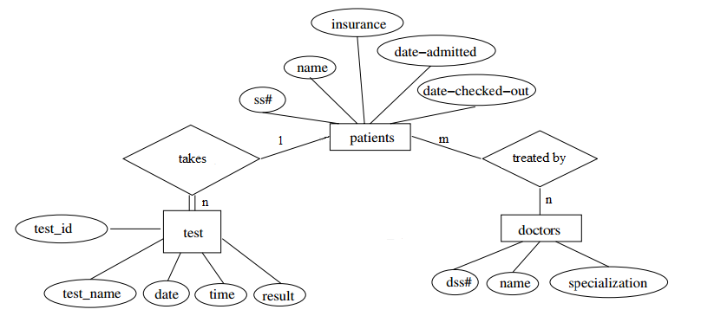Note the questions (2 & 3) do not contain sufficient information for building the two E/R diagrams. The answers are only samples.

For Q2, it is assumed that some cars in the company do not belong to any customers. An accident may involve more than one car. A car may be owned by more than one customer.

For Q3, a patient may have more than one doctor. Each test has a unique test ID.